Name: ______________________________
Date: ____/____/_____
Class Period:#________

Rikki-Tikki-Tavi by Rudyard Kipling

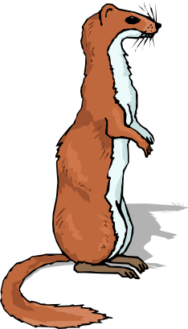
- As you read the short story, “Rikki-Tikki-Tavi,” you were introduced to conflict between the cobra and the mongoose, two natural enemies.

- Using the articles from National Geographic, fill in the chart below. Write down the characteristics of a mongoose and a cobra.

http://www.encyclopedia.com/topic/mongoose.aspx
http://www.encyclopedia.com/topic/cobra.aspx

Comparison Chart

Animal | Habitat | Size | Description of what it looks like | Value to Society
Mongoose

Similarities

Differences

Cobra

